Automatic Non-electric Solar Tracking Device
Amod Argade
Vishwakarma Institute of Technology
Pune, India
amod.argade22@vit.edu

Pranav Bedekar
Vishwakarma Institute of Technology
Pune, India
pranav.bedekar22@vit.edu

Mangesh Bahir
Vishwakarma Institute of Technology
Pune, India
mangesh.bahir22@vit.edu
Atharva Shinde
Vishwakarma Institute of Technology
Pune, India
atharva.shinde22@vit.edu

Alok Dadhich
Vishwakarma Institute of Technology
Pune, India
alok.dadhich22@vit.edu

Prof. D. B. Hulwan
Vishwakarma Institute of Technology
Pune, India
dattatray.hulwan@vit.edu

Abstract- Solar energy is pivotal in the transition to sustainable energy sources. This paper presents the design, fabrication, and testing of an automatic non-electric solar tracking system using R134a refrigerant. The system employs a passive mechanism that eliminates the need for external power or complex electronics, enhancing solar panel power output by approximately 22%. Experimental results validate the system's effectiveness, demonstrating its potential as a cost-effective and eco-friendly solution for maximizing solar energy capture.

Keywords- passive solar tracking, refrigerant-based tracking, R134a refrigerant, solar efficiency, non-electric tracker, renewable energy, photovoltaic optimization.

- Introduction

The increasing demand for renewable energy has driven innovations in solar power technology. Solar energy, being abundant and clean, is among the most promising renewable sources. However, the efficiency of solar panels is often constrained by their static orientation, limiting the amount of sunlight they can capture throughout the day. Solar tracking systems address this issue by aligning the panels with the sun’s path, thus maximizing energy capture​. While active solar tracking systems rely on motors, sensors, and external power sources, they are often expensive and require regular maintenance. In contrast, passive solar tracking systems use natural forces such as thermal expansion and refrigerant pressure changes to adjust panel orientation. These systems are not only cost-effective but also low maintenance, making them particularly suitable for deployment in rural areas where access to electricity and technical support is limited​. In rural communities, reliable access to energy is crucial for supporting essential services, agricultural activities, and small businesses. Solar energy, coupled with passive tracking systems, can provide an independent and sustainable power source, reducing reliance on expensive and polluting fossil fuels. The passive solar tracking system discussed in this paper offers a practical solution for rural electrification, enhancing energy yield without adding operational complexity.

- Literature Review
Passive solar tracking systems leverage natural mechanisms to align solar panels with the sun, enhancing energy capture without external power input.
Holambe et al. (2015) and other researchers have explored thermal expansion-based designs, which utilize materials with different expansion rates to achieve solar tracking, enhancing efficiency by up to 28%[1]. Bhattacharjee and Shaikh (2015) proposed a bioinspired tracker using bimetallic strips that mimic the heliotropic behavior of plants[2]. Riad et al. (2019) explored Shape Memory Alloys (SMAs) for passive tracking, reporting a 39% energy gain[3].

Ali H.ALmukhtar et al. delves into enhancing solar panel tracking systems using PID and Lead-Lag compensators. It employs Simulink modeling to demonstrate improved system dynamics and energy efficiency, offering practical solutions for renewable energy optimization[4].
Aziz et al. proposes a dual axes solar tracking , with decentralized storage units to use when the main storage unit is fully charged[5].

In Chao-Kai Yang et. al
the authors present an innovative solar tracking system utilizing Fresnel lenses and Stirling engines. Their analysis highlights significant advancements in solar-thermal efficiency and the integration of renewable energy technologies[6].

Batayneh et al. (2019) designed a single-axis discrete tracker that optimizes energy capture while minimizing actuation frequency[7]. Kim and Cho (2019) developed a hybrid system with Bayesian algorithm selection, improving efficiency by adapting to changing weather conditions[8]. AL-Rousan, N. et al. (2018) reviewed advances in solar tracking technologies, discussing various approaches, including passive and active methods, for efficiency improvements[9].
Zhang, J. et al. (2019) investigated a hybrid solar tracking system's error-correction methods to maximize accuracy and energy efficiency[10]. Hua et. al studied different types of solar trackers to comprehend the operational characteristics , as each one would produce different electrical output , they also studied the panel in various weather conditions[11].
Abdollahpour, M. et al. (2018)​ introduced a dual-axis tracker leveraging machine vision to align panels precisely, boosting energy efficiency in real-time conditions[12].
Ghassoul, M. (2018) introduced a PILOT-based automatic tracking mechanism to improve energy capture precision in solar panels[13].
Active trackers provide precision but at higher operational costs. Vieira et al. (2016) and Sharaf Eldin et al. (2016) evaluated the performance of active singleaxis trackers in equatorial and hot climates, showing significant energy gains[14,15].

Perini et al. implemented a dual axis tracking system with linear Fresnel lens collector , they found that the efficiency dropped by 20% due to optical losses , furthermore the efficiency increased after insulating with evacuated receiver[16].
Yao et al. implemented a dual axis tracking system withdeclination clock mounting system , they found that the Average energy efficiency of normal tracking with respect to that of fixed PV is more than 23.6% [17].
Fathabadi tested a dual axis solar tracker with sensor
& sensor less feature , they found that the average captured solar energy with sensor feature is 35.22% in one year & that for sensor less is 24.59% in one year[18]. Away & Ikhsan implemented a Dual axis solar tracker with three identical LDRs in tetrahedron shape and found that the model has a wide field of view, accuracy & effectiveness as compared with
previous types of model[19]. Abdallah & Nijmeh implemented a Dual axis solar tracker with PLC to
control the motion of solar tracking system and found Increment in total daily collectionof about 41.34% as compared with that of 32◦ tilted fixed surface[20].
Chen et al. implemented a Field programmable gate array [FPGA] based intelligent sun tracking system with the usage of NI9642 controller to integrate dual axis solar tracker with Maximum Power Point Tracker.
This system is assist with MATLAB so that the system can be switched to dual axis solar tracker, one axis solar tracker & fixed solar panel according to the need of the user[21]. Roth et al. Closed loop dual axis solar tracking system with four quadrant photo detectors & 2 small D.C. servo motors & a pyrheliometer for direct solar radiation measurement a z-80 processor they found at solar irradiance below 140 W/m2, the radiation falls nearly to zero but above this the system works fine[22]. Barker et al. implemented a low profile 2 axis solar tracker with unique linkage geometry (2 coplanar & perpendicular linear actuators coupled with a single linkage arm & pivots) was used to minimize the shading by adjacent trackers. They found compared existing mast style trackers, no significant change in shadow footprint was observed [23]. Skouri et al. compared 3 pilot dual axis sun tracking system (LDR based, date & time based using screw nut actuators, date & time based using reduction gear units) they found date & time based sun tracker using reduction gear units was more stable & accurate[24].

- Materials and Methods
Transesterification Solar Panel (6 V, 3 W): A solar cell panel, also known as a solar electric panel, photovoltaic (PV) module, or simply solar panel, is a collection of photovoltaic cells that are put in a framework for installation. The sun’s energy is converted into electricity using solar panel.

Canister (Gas Cylinders): Canisters are used to store refrigerants. This project calls for the usage of two cylindrical canisters. A valve is linked to one end of the canister, which is used to receive the contents that must be stored in it.

R134a Refrigerant: Tetrafluroethane (CF3CH2F) is another name for R134a, which belongs to the HFC (Hydro Floro Carbon) refrigerant family. For temperature increase, R134a liquid refrigerant is employed because of its low boiling point and high vapour pressure. R134a has the following properties:

- Boiling Point: 14.9⁰F or 26.1⁰C
- Auto-Ignition Temperature: 770⁰C
- Ozone Depletion Level = 0
- Water Solubility = 0.11 percent by weight at 77⁰F or 25⁰C
- Critical Temperature = 252⁰F or 122⁰C
- Global Warming Potential (GWP) = 1200

Gas Pipe: Gas is transferred from one cylinder to another using a gas pipe. One end of the gas line is linked to one canister and the other end to another canister in this project. The liquid refrigerant is pumped from one canister to the next via the gas pipe.

Stand and Frame: Stand and Frame are made up of stainless steel . Stand is used to give support to the frame. The stand is connected with frame which withstands the frame and make frame to move. Frame is used to withstand solar panel and canisters. Frame holds the canister on both sides and solar panel in the center.

Shielding plate: It’s used to cover a canister and create a pressure differential between two canisters, allowing liquid refrigerant to flow from one to the other. The components used in passive solar tracking system are:
- Solar panel (6 V,3W).
- Refrigerant (R-134a).
- Canisters (Aluminium).
- Brass conduit with brass valves.
- Shadow plate for differential heating of each canister (Cardboard).
- Frame (Stainless steel) and Shaft (Mild Steel).

Fig 1. Refrigerant R-134a

- CAD model

A 3D CAD model was successfully created using Fusion 360, showcasing its capabilities for precise design and engineering workflows.

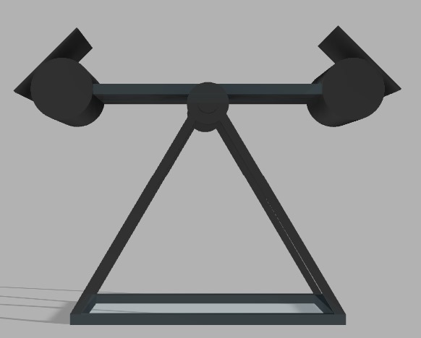
Figure 2. 3D CAD Model – Side view

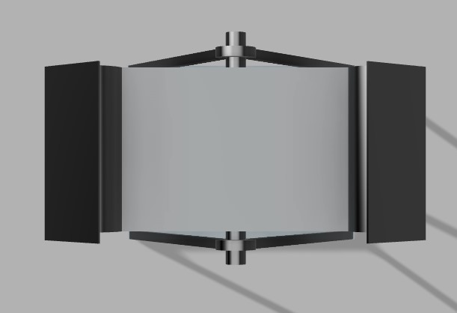
Figure 3. 3D CAD Model – Top view
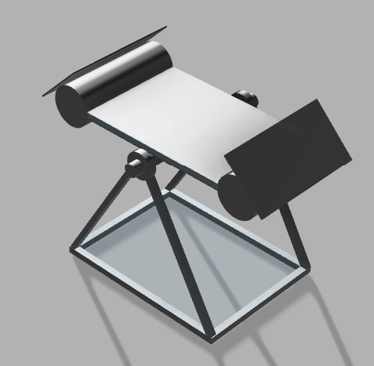
Figure 4. 3D CAD Model – Isometric view
2. Fabricated model

The fabrication of the model was completed successfully. The main frame was constructed using stainless steel, while the shaft was made from mild steel. The solar panel was securely mounted onto the frame, and canisters were fitted into designated slots. Shadow plates were attached to the canisters at an optimal angle, determined through experimentation.

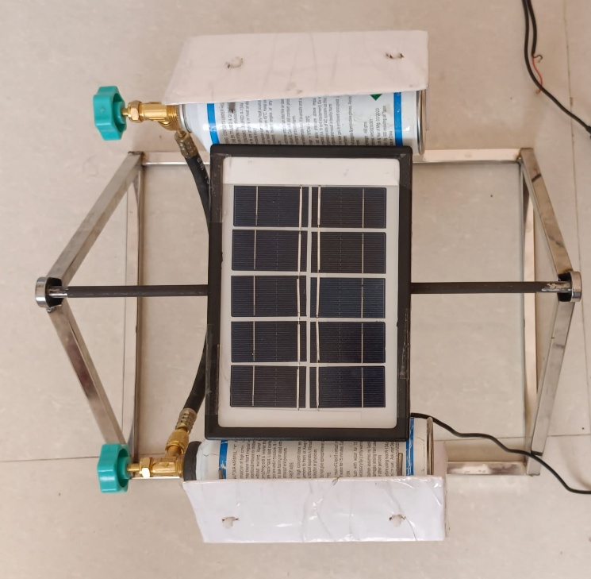
Figure 5. Actual Fabricated & Assembled Model
Figure 5 illustrates the fully fabricated and assembled model.

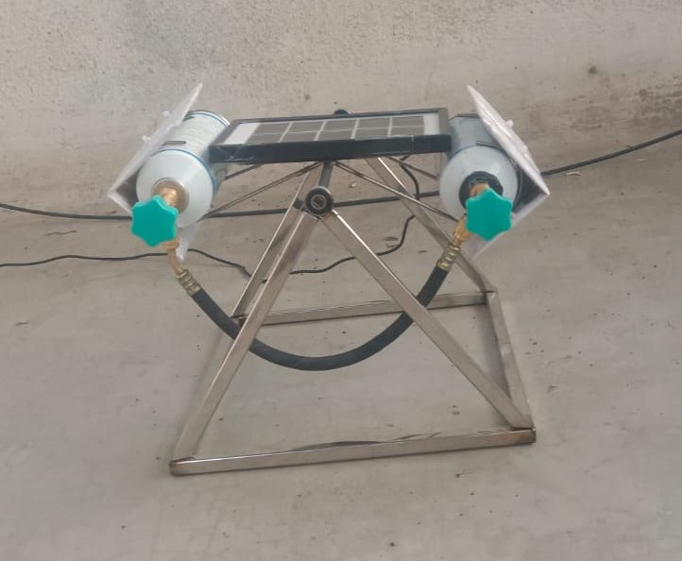
Figure 6. Side View of Model

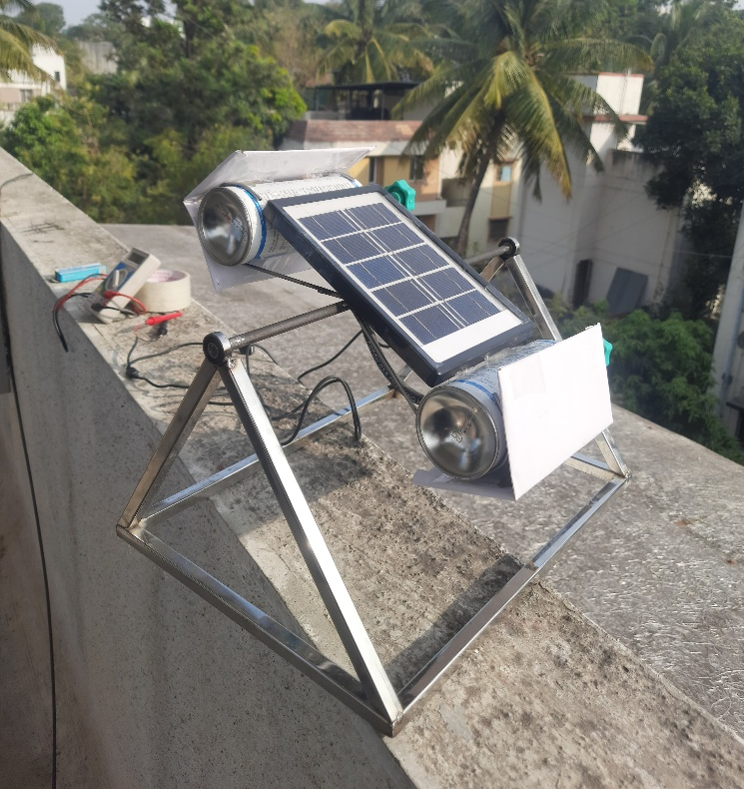
Figure 7. Working Model while taking readings
Figure 7 depicts the functioning of the model and demonstrates how readings were measured using a digital multimeter.

- Working Principle

The passive solar tracking system works by exploiting the differential heating of two canisters filled with R134a refrigerant, which drives the motion of the solar panel. The system consists of two canisters, placed on opposite sides of the solar panel frame: the east canister and the west canister. Initially, both canisters contain the same amount of refrigerant, and the system is balanced with the frame in a straight position.

When the solar panel is exposed to sunlight in the morning, the west canister, which faces the sun, absorbs the heat. As the sunlight heats up the west canister, the refrigerant inside it begins to vaporize, increasing the vapor pressure in that canister. This causes the refrigerant to move from the west canister to the east canister, where the vapor pressure is lower. As more refrigerant flows into the east canister, the increased weight shifts the frame, causing it to tilt towards the east.

Throughout the day, as the sun moves from east to west, the amount of sunlight hitting each canister changes, altering the vapor pressure in each canister. By midday, when the sun is nearly overhead, both canisters receive an equal amount of sunlight, causing the vapor pressure to balance out and equal amounts of refrigerant remain in both canisters. This results in the frame becoming balanced and straight again.
In the afternoon, as the sun moves westward, the east canister begins to heat up again, leading to the vaporization of the refrigerant and an increase in vapor
pressure. This causes the refrigerant to move from the east canister to the west canister, shifting the frame towards the west. By evening, the movement of refrigerant from the east canister to the west canister restores the panel to its original position, preparing it for the next day.

This cyclical movement based on the position and intensity of sunlight ensures that the solar panel remains aligned with the sun throughout the day, maximizing energy capture.

- Results and Discussions

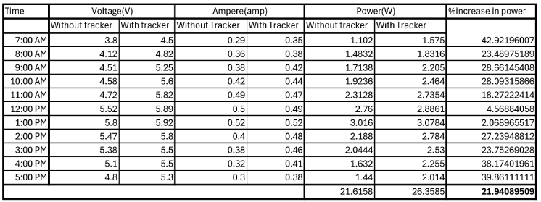
Figure 8. Readings taken from Model

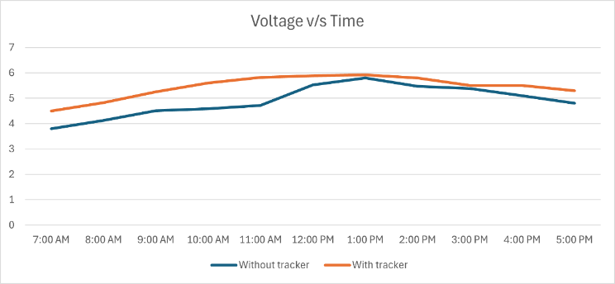
Figure 9 Voltage vs Time Graph
Graph 9 compares voltage vs. time for solar panels with and without a tracker from 7:00 AM to 5:00 PM. The "With Tracker" line demonstrates consistently higher voltage output as the tracker optimizes the panel's angle to maximize sunlight capture throughout the day. Both lines peak around noon when sunlight intensity is highest, but the "Without Tracker" line shows lower voltages, especially in the morning and late afternoon, due to the fixed panel's inability to adjust to the sun's position. This highlights the tracker’s effectiveness in enhancing energy output.

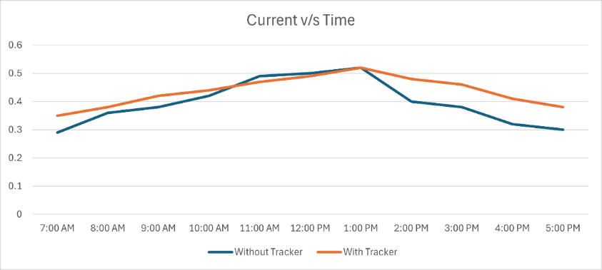
Figure 10 Current vs Time
Graph 3 shows the comparison of current generated by solar panels with and without a tracker from 7:00 AM to 5:00 PM. The "With Tracker" line consistently shows higher current values throughout the day as the tracker adjusts the panel's angle to directly face the sun, maximizing sunlight capture. The current peaks at around 12:00 PM in both cases, as this is when the sun is at its highest point. However, the "Without Tracker" line declines more steeply in the morning and afternoon due to the fixed panel angle, making it less effective at capturing sunlight during these times.

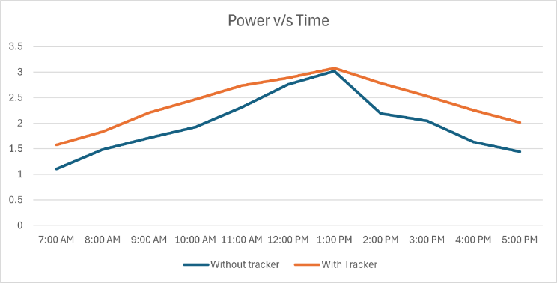
Figure 11 Power vs Time
Graph 4 compares power vs. time for solar panels with and without a tracker from 7:00 AM to 5:00 PM. The "With Tracker" line shows consistently higher power output as the tracker adjusts the panel's angle to optimize sunlight capture. Both lines peak around 1:00 PM, but the "Without Tracker" line indicates lower power, especially in the morning and late afternoon, due to the fixed panel's inability to follow the sun's movement. This emphasizes the tracker’s role in improving energy production throughout the day.

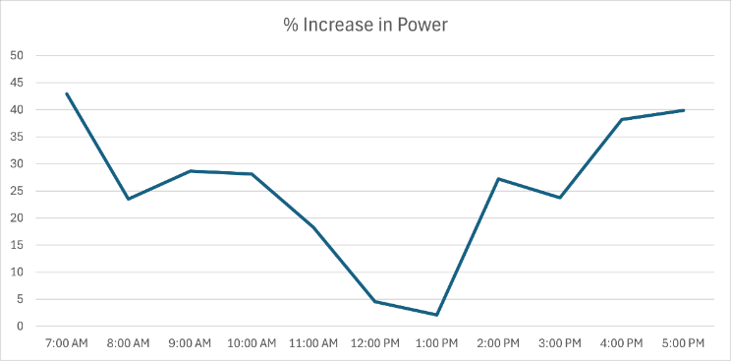
Figure 12 % Increase in Power
Graph 5 illustrates the percentage increase in power due to the tracker system over the same time period. The highest gains are observed early in the morning (around 45%) and late afternoon (close to 40%), as the tracker compensates for rapid changes in the sun's angle. Gains decrease slightly near noon, aligning with maximum sunlight intensity. This highlights the tracker's efficiency in maintaining optimal energy output during non-peak sunlight hours.

- Conclusion
The power generated by a solar panel depends on the sun's direction and intensity. Fixed solar panels, which cannot adjust to the sun’s movement, have lower efficiency compared to mobile solar panels. To achieve a significant increase in electricity output, it is essential to track the sun’s position and align the solar panel accordingly. This study introduces a passive solar tracking system that uses a liquid refrigerant, which increases its vapor pressure with temperature. The movement of the refrigerant shifts the weight balance, enabling the model to track the sun’s position without consuming additional power. The results show more than a 20% increase in power generation using this system.
The study concludes that solar energy conversion systems, such as solar collectors and photovoltaic systems, require tracking the sun’s movement to maximize light utilization and conversion efficiency. By employing a refrigerant-based tracking system, the solar panel continuously adjusts to the sun’s position, ensuring continuous energy extraction and a notable increase in output power.
References

- Holambe, Prabhakar & Talange, D. & Bhole, Vinodini. (2015). Motorless solar tracking system. 358-363. 10.1109/ICESA.2015.7503371.

- Amrita Bhattacharjee, Saad Ahmed Shaikh, (2023) Design of a nature-inspired sun-tracking device in context of rural India, Energy Reports, Volume 10, Pages 4651-4658, ISSN 2352-4847, https://doi.org/10.1016/j.egyr.2023.11.026.

- Amine Riad and Abdelilah Alhamany and Mouna Benzohra ,(2017) , The shape memory alloy actuator controlled by the Sun’s radiation , IOP Publishing , Volume 4 , https://dx.doi.org/10.1088/2053-1591/aa75bb

- Almukhtar, A.H. (2013). Design of Phase Compensation for Solar Panel Systems for Tracking Sun. Energy Procedia, 36, 9-23.

- Aziz, S., & Hassan, S. (2017). On Improving the Efficiency of a Solar Panel Tracking System. Procedia Manufacturing, 7, 218-224.

- Yang, C.-K., Cheng, T.-C., Cheng, C.-H., Wang, C.-C., & Lee, C.-C. (2017). Open-loop altitude-azimuth concentrated solar tracking system. Solar Energy, 147, 52-60.

- Batayneh, W., Bataineh, A., Soliman, I., & Hafees, S.A. (2019). Investigation of a single-axis discrete solar tracking system. Automation in Construction, 98, 102109.

- Kim, K.-H., & Cho, S.-B. (2019). An efficient concentrative photovoltaic solar system with Bayesian selection. Applied Soft Computing, 83, 105618.

- AL-Rousan, N., Isa, N.A.M., & Desa, M.K.M. (2018). Advances in solar photovoltaic tracking systems: A review. Renewable and Sustainable Energy Reviews, 82, 2548-2569.

- Zhang, J., Yin, Z., & Jin, P. (2019). Error analysis and auto correction of hybrid solar tracking system. Energy, 182, 585-593.

- Hua, Z., Ma, C., Ma, M., Bin, L., & Pang, X. (2019). Operation characteristics of multiple solar trackers. Energy Procedia, 158, 6242-6247.

- Abdollahpour, M., Golzarian, M.R., & Rohani, A. (2018). Development of a machine vision dual-axis solar tracking system. Solar Energy, 169, 136-143.

- Ghassoul, M. (2018). Single axis automatic tracking system based on PILOT scheme. Energy Reports, 4, 520-527.

- Vieira, R.G., Guerra, F.K.O.M.V., Vale, M.R.B.G., & Araújo, M.M. (2016). Comparative performance analysis between static solar panels and single-axis tracking system. Renewable and Sustainable Energy Reviews, 64, 672-681.

- Sharaf Eldin, S.A., Abd-Elhady, M.S., & Kandil, H.A. (2016). Feasibility of solar tracking systems for PV panels in hot and cold regions. Renewable Energy, 85, 228-233.

- Perini, Simoni, Tonnellier, Xavier, King, Peter, Sansom, Christopher, 2017. Theoretical and experimental analysis of an innovative dual-axis tracking linear Fresnel lenses concentrated solar thermal collector. Sol. Energy 153, 679–690. http://dx.doi.org/10.1016/j.solener.2017.06.010.

- Yao, Yingxue, Hu, Yegaung, Gao, Shengdong, Yang, Gang, Du, Jinguang, 2014. A multipurpose dual-axis solar tracker with two tracking strategies. Renew. Energy 72, 88–98. http://dx.doi.org/10.1016/j.renene.2014.07.002.

- Fathabadi, Hassan, 2016. Comparative study of two novel sensorless and sensor based dual-axis solar trackers. Sol. Energy 138, 67–76. http://dx.doi.org/10.1016/j.solener.2016.09.009.

- Away, Yuwaldi, Ikhsan, M., 2016. Dual-axis sun tracker sensor based on tetrahedron geometry. Autom. Constr. http://dx.doi.org/10.1016/j.autcon.2016.10.009

- Abdallah, Salah, Nijmeh, Salem, 2004. Two axes solar tracking system with PLC control. Energy Convers. Manage. 45 (11–12), 1931–1939. http://dx.doi.org/10.1016/j.enconman.2003.10.007

- Chen, Jui-Ho, Yau, Her-Terng, Hung, Tzu-Hsiang, 2015. Design and implementation of FPGA-based Taguchi-chaos-PSO Sun tracking systems. Mechatronics25, 55–64. http://dx.doi.org/10.1016/j.mechatronics.2014.12.004

- Roth, P., Georgiev, A., Boudinov, H., 2004. Design and construction of a system for Sun-tracking. Renew. Energy 29, 393–402. http://dx.doi.org/10.1016/S09601481(03)00196-4.

- Barker, Laughlin, Neber, Matthew, Lee, Hohyun, 2013. Design of a low profile two-axis solar tracker. Sol. Energy 97, 569–576. http://dx.doi.org/10.1016/j.solener.2013.09.014.

- Skouri, Safa, Ali, Abdessalem Ben Haj, Bouadila, Salwa, Salah, Mohieddine Ben,2016. Design and construction of Sun tracking systems for solar parabolic concentrator displacement. Renew. Sustain. Energy 60, 1419–1429. http://dx.doi.org/10.1016/j.rser.2016.03.006

